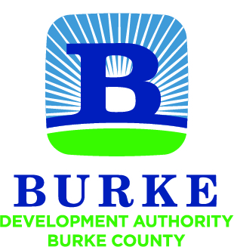

Development Authority of Burke County
Regular Monthly Meeting

All meetings of the Development Authority of Burke County shall be held in accordance with the provisions of O.C.G.A. § 50-14-1 et seq. The public shall at all times be afforded access to all meetings other than executive sessions.

January 24, 2017 10:00 AM

- Call to Order W.H. Harper, Jr.

- Intergovernmental Agreement for SPLOST IV

- Option to Purchase Property

- Approval of Minutes (11.22.16 and 12.29.16)

- Financial Report Merv Waldrop

  - Account Balances
  - SPLOST Disbursements

- Staff Reports / Updates Jessica Hood

  - Activity Update
    - Update - Bradley
    - Update – Red Carpet
    - Contracts / Purchases for Red Carpet Tour

  - Partner Updates

NEXT MEETING February 28, 2017
10:00 AM

