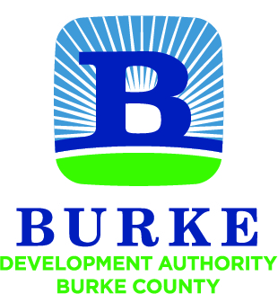

Development Authority of Burke County
Regular Monthly Meeting

All meetings of the Development Authority of Burke County shall be held in accordance with the provisions of O.C.G.A. § 50-14-1 et seq. The public shall at all times be afforded access to all meetings other than executive sessions.

February 28, 2017 9:00 AM

- Call to Order W.H. Harper, Jr.

- Approval of Minutes

- Financial Report Merv Waldrop

  - Account Balances
  - SPLOST Disbursements

- Staff Reports / Updates Jessica Hood

  - Year to Date Budget Report

  - Activity Update

    - Project Bradley
    - Project Golden Eagle
    - Project Red Carpet
    - Request for Chair to Appoint Board Member
to RFP Evaluation Committee

  - Partner Updates

NEXT MEETING March 28, 2017
10:00 AM

