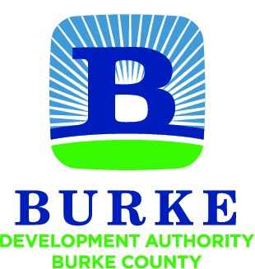

Development Authority of Burke County
Regular Monthly Meeting

All meetings of the Development Authority of Burke County shall be held in accordance with the provisions of O.C.G.A. § 50-14-1 et seq. The public shall at all times be afforded access to all meetings other than executive sessions.

August 15, 2017 10:00 AM

- Call to Order W.H. Harper, Jr.

- Approval of Minutes

- Financial Report Merv Waldrop

  - Account Balances
  - SPLOST Disbursements
  - YTD Budget Report Jessica Hood

- Staff Reports Jessica Hood

  - Activity Report
  - Board Member Reappointments

- Partner Updates

NEXT MEETING September 26, 2017
10:00 AM

