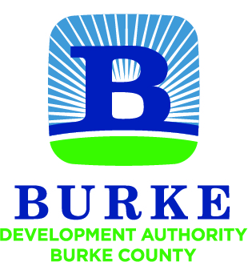

Development Authority of Burke County

Regular Monthly Meeting

All meetings of the Development Authority of Burke County shall be held in accordance with the provisions of O.C.G.A. § 50-14-1 et seq. The public shall at all times be afforded access to all meetings other than executive sessions.

June 26, 2018 8:00 AM

- Call to Order Preston Conner

- Approval of Minutes Preston Conner

- Financial Report Merv Waldrop

  - Account Balances
  - SPLOST Disbursements
  - YTD Budget Report FY 18 Jessica Hood

- Approval of FY 19 Budget Jessica Hood

- E-Commerce Tax Exemption Jessica Hood

- 3-County JDA Creation / Activation Jessica Hood

- GRAD Certification for Raymond Tract Jessica Hood

- Project Chef Financing Options Jessica Hood

NEXT MEETING July 24, 2018
8:00 AM

